Matthew Tran
Breaking Ciphers and Hashes: Cipher and MD5 Collision Lab
The purpose of this lab was to learn how basic encryption and hashing systems work and why some of them are no longer secure. In the first part of the lab, I worked with a substitution cipher and used frequency analysis to see how encrypted text can be cracked. In the second part, I performed an MD5 collision attack to understand why MD5 is considered unsafe today. This lab showed how small weaknesses in cryptography can lead to serious security problems.
Tools Used
- Python
- GCC
- md5collgen
- Wireshark Virtual Machine
- Linux terminal commands (tr, cat, head, tail, md5sum)
Skills Learned
- Creating and breaking substitution ciphers
- Using frequency analysis to crack encrypted text
- Understanding MD5 hash collisions
- Working with binary files
- Recognizing why outdated cryptographic algorithms are insecure

Task 1) Creating a Random Substitution Key
- Opened the terminal inside my manually created virtual machine.
- Used vim to create a Python file named key.py.
- Wrote Python code that used the random.sample() function to shuffle the lowercase alphabet.
- Printed both the original alphabet and the generated substitution key to the terminal.
- Ran the script using python3 key.py to generate the key.
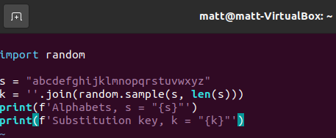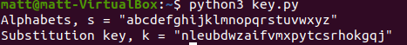
This step created a random substitution key that replaces each letter with another letter. This key is required to encrypt plaintext using a monoalphabetic cipher.
Task 2) Cleaning the Original Text
- Used the tr command to convert all uppercase letters in article.txt to lowercase.
- Saved the output to a file named lowercase.txt.
- Used another tr command to remove punctuation and numbers from the text.
- Saved the cleaned output to plaintext.txt.
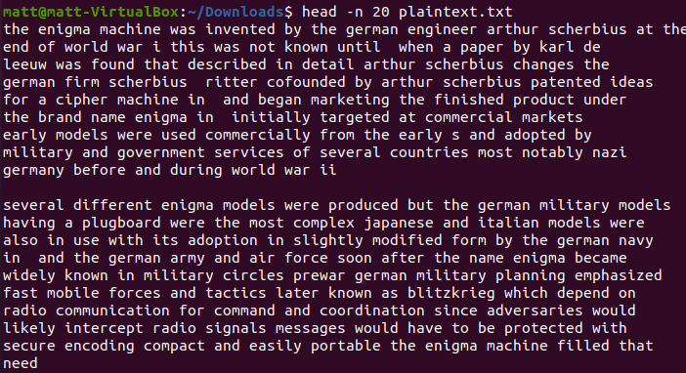
The first command I used converted all uppercase letters to lowercase. The second command would remove all characters that weren’t a space or lowercase letter. Although everything does look more clumped up, the text also looks much more consistent for any needed analysis.
Task 3: Encrypting the Plaintext
- Identified the original alphabet and the generated substitution key.
- Used the tr command to map each letter to its encrypted version.
- Left spaces unchanged during encryption.
- Saved the encrypted output to ciphertext.txt.
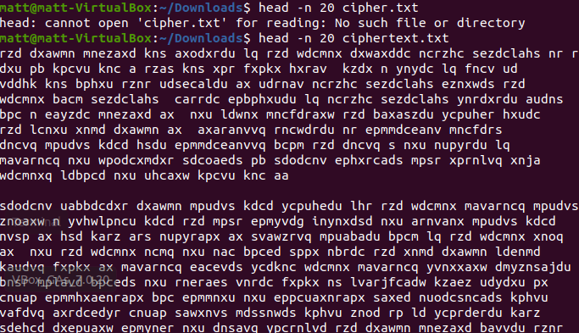
The command used would change the original used alphabet into the key (abcdefghijklmnopqrstuvwxyz to nleubdwzaifvmxpytcsrhokgqj). Although all of the original letters and words have been scrambled the spaces still remain the same.
Task 4) Frequency Analysis of the Ciphertext
- Created a Python file named freq.py using vim.
- Wrote code to read ciphertext.txt and count letter patterns.
- Calculated single-letter, bigram, and trigram frequencies.
- Ran the script to display the most common patterns.
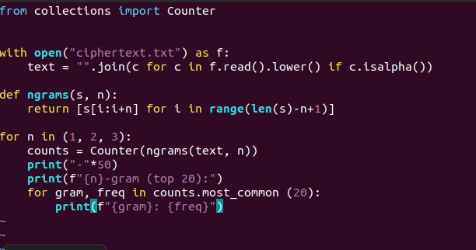
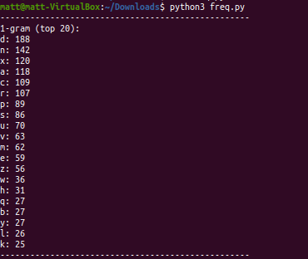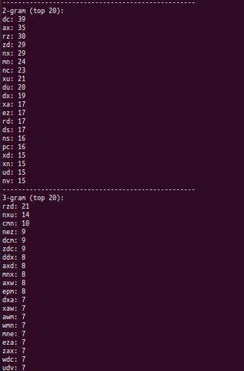
I wrote a script called freq.py that will read the ciphertext.txt file and filter out non=letter characters. It would count the occurrences of n-grams. 1- gram, the most frequent letters in 1-gram are d, n, and x. 2- gram, the most frequent bigrams are dx, an, and rz. 3- gram, the most frequent trigrams are rzd, nxu, and cmn. When looking at the numbers I am able to try and convert the most found grams into their original states. For example, the trigram rzd was found 21 times and when converted back it would spell the word” the.” Even though it looks extremely confusing at first, it is a little insane that you can decipher letter by letter possibly just by trying to find commonalities or repetitions of certain letters or words that would usually be so common in normal speech.
Task 5) Understanding MD5 Collision Properties
- Used md5sum to compare the hashes of two different files.
- Observed that the files produced the same MD5 hash.
- Used the cat command to combine the files.
- Generated a new hash for the combined file.
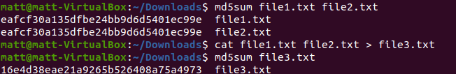
We first use md5sum to observe that these two different inputs have the same MD5 hash. I am then able to understand that they are a collision pair and that I can use cat to combine them into one file. It is interesting though to see that two inputs that had the same md5sum combined give me a file with a new MD5 hash.
Task 6) Creating a Program for Collision Injection
- Created a C file named task3.c.
- Initialized a 400-byte array filled with the character 'A'.
- Compiled the program using gcc to create an executable.
- Verified the program printed hexadecimal values.
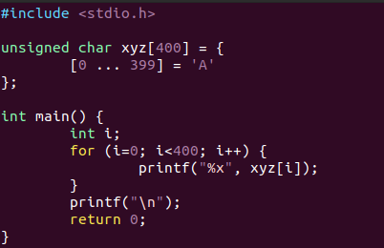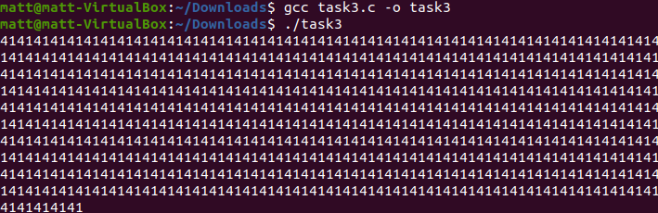
I wrote a C program that initializes a 400-byte array with value ‘A.’ This will then print the hex value values of that array, which is 41 in this case.
Task 7) Splitting the Executable File
- Used head to extract the prefix of the executable.
- Used tail to extract the suffix.
- Ensured the prefix length was a multiple of 64 bytes.
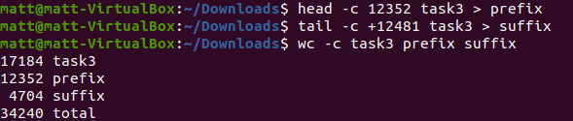
Task 8: Generating the MD5 Collision
- Ran the md5collgen tool on the prefix.
- Generated two files named t1.bin and t2.bin.
- Verified both files had the same MD5 hash.
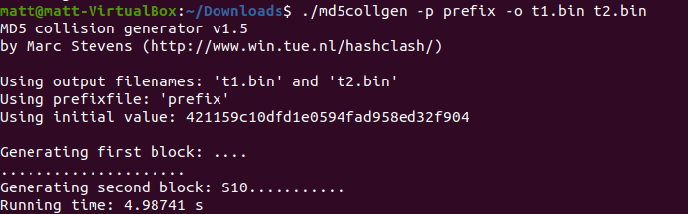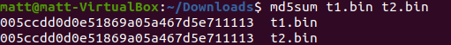
I used the md5collgen tool on the prefix file. I had to add the “./” before the md5collgen since it wasn’t allowing me to use md5collgen alone. This tool generated two different outputs, t1.bin and t2.bin. They have the same MD5 hash.
Task 9: Building the Final Executables
- Extracted the last 128 bytes from each collision file.
- Appended the prefix, collision block, and suffix together.
- Created two final executables: a1.out and a2.out.
- Verified hashes using md5sum and sha256sum.
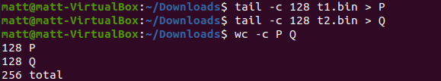
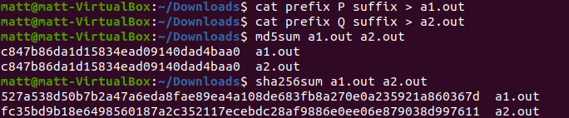
I created two executables by combining the pieces. I then double checked their hashes. The MD5 hashes were the same but the sha256 hashes were different. This showed me how if an attacker created a program with a malicious intent and it had the same MD5 hash as another normal and probably beneficial program, it would be so easy to bypass security systems that use MD5 for any type of verification. Sha256 showed the difference between the two and why MD5 is too weak and unsafe for today’s confidentiality and authentication, when it comes to modern society’s technological knowledge of cybersecurity.

